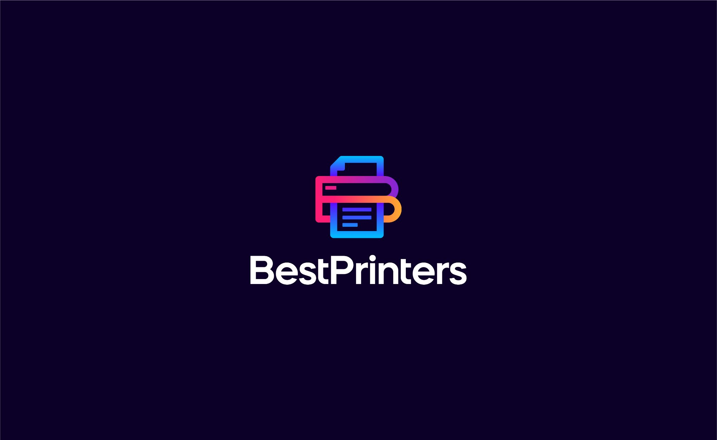

The Complete Printer Buying Guide
Find Your Perfect Printer in Minutes

Why Choosing the Right Printer Matters
Buying a printer shouldn't be complicated. Yet with hundreds of models on the market, each claiming to be the best, it's easy to feel overwhelmed. The wrong printer can cost you time and money through expensive ink, slow speeds, or missing features you actually need.
That's where BestPrintersTech.com comes in. Our smart printer finder takes the guesswork out of shopping by matching you with the perfect printer based on your actual needs—not marketing hype.

How Our Printer Finder Works
Finding your ideal printer is as simple as answering 9 quick questions. Our intelligent questionnaire analyzes your:
- Printing volume and frequency
- Color vs. black and white needs
- Budget constraints
- Required features (scanning, copying, wireless)
- Print quality requirements
- Speed priorities
Based on your answers, we provide personalized recommendations that match your specific situation—whether you're a student on a budget, a small business owner, or a photography enthusiast.

The 9 Essential Questions
Here's what our questionnaire covers to ensure you get the perfect printer match:

1. What Will You Primarily Use This Printer For?
Different environments have different demands. A home printer handles occasional family documents, while an enterprise printer must tackle thousands of pages daily. We help you find the right capacity and features for your environment.
- Home/personal use
- Small office/business
- Large office/enterprise
- Student/school work

2. How Much Do You Print Per Month?
Understanding your print volume is crucial for calculating long-term costs. Light users need affordable upfront prices, while heavy users require low per-page costs to avoid breaking the bank on ink or toner.
- Light (less than 100 pages)
- Moderate (100-500 pages)
- Heavy (500-2,000 pages)
- Very heavy (2,000+ pages)

3. Do You Need Color Printing?
Color adds cost—both in hardware and consumables. If you only print text documents, a black and white printer saves significantly. But if you need graphics, presentations, or photos, color capability is essential.
- Black & white only
- Color printing needed
- Not sure

4. What Will You Print Most Often?
The type of content you print determines the technology you need. Laser excels at crisp text, inkjet produces vibrant photos, and specialized printers handle marketing materials. Matching your content to the right technology ensures quality results.
- Documents and text
- Photos
- Graphics/marketing materials
- Mixed (documents + photos)

5. Do You Need Scanning or Copying Features?
All-in-one printers combine printing, scanning, copying, and sometimes faxing in one device. They're ideal for offices and busy households but cost more. If you only need basic printing, a standalone printer saves money.
- Printer only
- Printer + scanner
- All-in-one (print, scan, copy, fax)

6. What's Your Budget?
Remember: the cheapest printer isn't always the most economical. Consider total cost of ownership including ink or toner over time. Our recommendations balance upfront costs with long-term expenses based on your usage.
- Under $100
- $100-$300
- $300-$600
- Over $600

7. How Important Is Print Speed?
If you print occasionally, speed doesn't matter much. But for busy offices or time-sensitive work, waiting for slow prints adds up. We match you with printers that fit your pace without overpaying for speed you don't need.
- Not important (occasional use)
- Somewhat important
- Very important (time-sensitive work)

8. Do You Prefer Ink or Laser?
Inkjet printers excel at photos and color graphics with lower upfront costs. Laser printers offer faster speeds and cheaper per-page costs for text documents. Not sure which is right? We'll guide you based on your printing habits.
- Inkjet (better for photos, color)
- Laser (faster, cheaper per page for documents)
- No preference

9. Do You Need Wireless/Mobile Printing?
Wireless connectivity lets you print from smartphones, tablets, and laptops anywhere in your home or office. It's convenient but adds to the price. If you print from one computer, a USB connection works fine.
- Yes, must have WiFi
- Nice to have, but not essential
- No, USB connection is fine

Understanding Printer Technology

Inkjet vs. Laser: Which Is Right for You?
Inkjet Printers
- Best for: Photos, color graphics, home use
- Pros: Lower upfront cost, excellent photo quality, compact size
- Cons: Higher ink costs, slower speeds, ink can dry out

Laser Printers
- Best for: Text documents, high-volume printing, offices
- Pros: Fast speeds, low per-page cost, toner doesn't dry out
- Cons: Higher upfront cost, larger size, mediocre photo quality

Hidden Costs to Watch Out For
The printer's price tag is just the beginning. Here's what really impacts your wallet:

Ink and Toner Costs
A $50 printer can cost you $500 per year in ink if you print frequently. Always check the cost per page (CPP) for both black and color printing. Laser printers typically offer CPP of 2-3 cents, while budget inkjets can hit 15-20 cents per page.

Subscription Services
Many manufacturers now offer ink subscription programs like HP Instant Ink or Epson ReadyPrint. These can save money for regular users but lock you into monthly fees. Our questionnaire helps determine if subscriptions make sense for your usage.

Maintenance and Repairs
Cheaper printers often have shorter lifespans and higher failure rates. Consider the warranty coverage and typical lifespan when making your choice. Sometimes paying more upfront saves headaches later.

Why Choose BestPrintersTech.com?

Unbiased Recommendations
We're not paid by manufacturers to push specific brands. Our algorithm analyzes hundreds of printers across all major brands to find the best match for your needs and budget.

Save Time and Money
Instead of spending hours researching reviews and comparing specs, get personalized recommendations in under 2 minutes. We calculate total cost of ownership, not just sticker price, so you know the real cost.

Expert Insights
Our team tests dozens of printers annually and stays current with the latest models. We translate technical jargon into plain English so you understand exactly what you're buying.

Regularly Updated Database
The printer market changes constantly with new models and price drops. Our database is updated weekly to ensure you get current recommendations with accurate pricing.

Getting Started Is Easy
- Visit BestPrintersTech.com
- Click on the Printer Finder tool
- Answer 9 quick questions about your printing needs
- Review your personalized printer recommendations
- Compare features, prices, and total ownership costs
- Make your purchase with confidence

Quick Tips for Printer Shopping
- Calculate cost per page, not just printer price – A $100 printer with expensive ink costs more over time than a $300 printer with cheap toner.
- Consider page yield – How many pages does one ink cartridge or toner produce? Higher yields mean fewer replacements.
- Check connectivity options – Modern printers should support WiFi, mobile printing apps, and cloud services for maximum flexibility.
- Read real user reviews – Look beyond star ratings for comments about reliability, print quality, and customer service.
- Verify warranty coverage – Longer warranties indicate manufacturer confidence and protect your investment.
- Think about future needs – If your printing volume might increase, choose a printer that can grow with you.

Start Finding Your Perfect Printer Today
Stop guessing and start printing with confidence. Whether you need a reliable workhorse for your home office, a photo printer for preserving memories, or an enterprise solution for high-volume printing, BestPrintersTech.com has the perfect match.
Our free Printer Finder questionnaire takes less than 2 minutes and provides instant, personalized recommendations based on your specific needs. No more buyer's remorse, no more expensive mistakes—just the right printer at the right price.
Visit BestPrintersTech.com now and discover your ideal printer!
Your perfect printing solution is just 9 questions away.

